Welcome to AWANA at Fellowship Community Church! We are so
excited that you are here! AWANA’s goal is “to reach boys and girls
with the gospel of Christ, and train them to serve Him.” It is our
desire that you and your children will truly know Christ and live
your lives glorifying Him.
Sundays 3:55pm to 5:00pm

Sundays 3:55 – 6:00 PM

September 13, 2015 – May

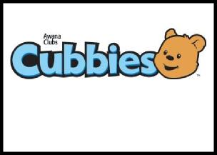
2 year olds (leaders’ kids only)
3 & 4 year olds
(Potty-trained only)
Kindergarten – 2nd Grade

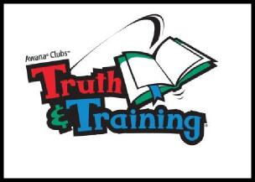
3rd - 5th Grades
6th – 8th Grades
9th – 12th Grades
2 Timothy 2:15
For more information contact Dave or Nancy Bruscher at 303-521-3454 or dnbruscher@msn.com

Fellowship Community Church
6263 S. Parker Rd, Centennial, CO 80016 * (303) 699-1110 * www.fcchurch.org

2020/2021 AWANA Calendar
Weather Cancellations will be posted on FCC’s website, www.fcchurch.org on Sunday after 1:00 PM. If you don’t have internet access call Dave Bruscher at
303-521-3454
10/11 AWANA Starts ----
10/18 Regular club night
10/25 PJ night – Wear Pajamas to club
11/01 Food Drive Begins - Bring canned goods
11/08 Food Drive Continues
11/15 Food Drive Continues ---- Sparks
ATTENTION PARENTS
Please Check your clubber in at
the AWANA desk when you arrive,
then go into opening ceremony
and stay for announcements.
All clubbers must
check in by 3:55 for
opening ceremony.
11/22 Food Drive Ends
11/29 Thanksgiving Break – NO AWANA
12/06 Regular club night
12/13 Regular club night
12/20 Holiday Sweater Night --- Sparks
12/27 Christmas Break – NO AWANA
01/03 New Year’s Break – NO AWANA
01/10 Regular club night
01/17 Regular club night
01/24 Bible Character Night – Dress as a Bible Character
01/31 Regular club night
Getting together is FUN.

But,
Don’t forget to wear your mask.
02/07 Super Bowl – NO AWANA
02/14 Grand Prix Kits on Sale
02/21 PJ night – Wear Pajamas to club
02/28 Regular club night
03/07 Regular club night
03/10 Wednesday Night 6:30 Grand Prix Workshop
03/14 Goofy Hat – Wear your Goofy Hat
03/17 Wednesday Night 6:30 Grand Prix Workshop
03/21 Regular club night
03/27 Grand Prix Race
03/28 Regular club night
04/04 Easter – NO AWANA
04/11 Regular club night
04/18 Crazy Hair Night
Pastor: Rick John
Commanders: Dave & Nancy Bruscher
Club Secretary: Sandy Alleckson
Cubbies Director: Chris and Bev Holtzem
Sparks Directory: Helen Gray
T&T Director: Curt Miller
Trek Director: Dave Bruscher
Journey Director: Dave Bruscher

04/25 Regular club night
05/02 Regular club night
05/09 Mother’s Day – NO AWANA
05/16 Regular club night
05/23 Regular club night
05/30 Memorial Weekend – NO AWANA
06/06 Award Ceremony

